CREATE TABLE ROOMS (

Rno int NOT NULL UNIQUE,

Rtype varchar(255) NOT NULL,

Rchargesperday decimal,

Roccupany text,

PRIMARY KEY (Rno)

);

CREATE TABLE BILLS (

Pid int NOT NULL,

Billdate date NOT NULL,

Medicineamount decimal,

Roomamount decimal,

PRIMARY KEY (Pid, Billdate)

);

CREATE TABLE PATIENT (

Pid int NOT NULL UNIQUE,

Pname varchar(255) NOT NULL,

Paddress varchar(255),

Pdob date,

Pphoneno varchar(10),

Psex char,

Pemail text,

Rno int,

Admitdate date,

Dischargedate date,

PRIMARY KEY (Pid),

FOREIGN KEY (Rno) REFERENCES ROOMS(Rno)

);

CREATE TABLE DOCTOR (

Did int NOT NULL UNIQUE,

Dname varchar(255) NOT NULL,

Daddress varchar(255),

Ddob date,

Dcabin text,

Dphoneno varchar(10),

Dsex char,

Demail text,

Dspecialization text,

Dworkingdays int,

Dworkinghrs decimal,

PRIMARY KEY (Did)

);

CREATE TABLE STAFF (

Sid int NOT NULL UNIQUE,

Sname varchar(255) NOT NULL,

Saddress varchar(255),

Sdob date,

Sphoneno varchar(10),

Ssex char,

Semail text,

Sdesignation text,

Sworkingdays int,

Sworkinghrs decimal,

PRIMARY KEY (Sid)

);

CREATE TABLE VISITS (

Pid int NOT NULL,

Did int NOT NULL,

Appointmentdate date NOT NULL,

PRIMARY KEY (Pid, Did, Appointmentdate)

);

CREATE TABLE ATTENDEDBY (

Pid int NOT NULL,

Sid int NOT NULL,

Attenddate date,

PRIMARY KEY (Pid, Sid,Attenddate)

);

INSERT INTO ROOMS Values(101,'ICU',1000,'occupied');

INSERT INTO ROOMS Values(102,'ICU',1000,'occupied');

INSERT INTO ROOMS Values(103,'Operation theatre',300,'occupied');

INSERT INTO ROOMS Values(104,'Operation theatre',300,'available');

INSERT INTO ROOMS Values(105,'Private ward',500,'occupied');

Select * from ROOMS;

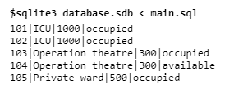

INSERT INTO PATIENT Values(1,'Ram','Delhi','1996-10-05','8679345623','M','ram@gmail.com',101,'17-05-02','17-05-08');

INSERT INTO PATIENT Values(2,'Rahul','Delhi','1996-11-10','9879345343','M','rahul@gmail.com',102,'16-05-02','16-05-08');

INSERT INTO PATIENT Values(3,'Radhika','Gurgoan','1996-08-04','9829345623','F','radhika@gmail.com',NULL,NULL,NULL);

INSERT INTO PATIENT Values(4,'Geeta','Faridabad','1994-08-06','9876545623','F','geeta@gmail.com',105,'17-05-02','17-05-08');

Select * from PATIENT;

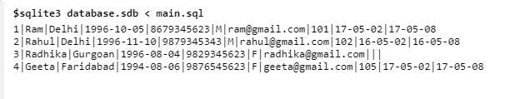

INSERT INTO DOCTOR Values(10,'Sameer','Delhi','1980-10-05','F101','9756345623','M','sameer@gmail.com','Çardiologist',20,5);

INSERT INTO DOCTOR Values(20,'Ajay','Noida','1989-11-02','S104','9847345623','M','ajay@gmail.com','Neurologist',15,6);

INSERT INTO DOCTOR Values(30,'Pradeep','Gurgoan','1972-08-04','S108','9867945623','M','pradeep@gmail.com','Orthopedist',25,4);

Select * from DOCTOR;

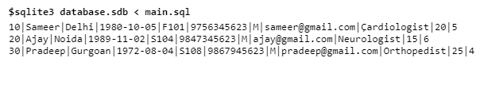

INSERT INTO STAFF Values(1,'Kiran','Delhi','1980-10-05','9756345623','F','kiran@gmail.com','Nurse',20,10);

INSERT INTO STAFF Values(2,'Mayur','Delhi','1989-05-03','8006345623','M','mayur@gmail.com','Ward boy',25,10);

INSERT INTO STAFF Values(3,'Karishma','Delhi','1990-05-09','8765445623','F','karishma@gmail.com','Nurse',26,10);

Select * from STAFF;

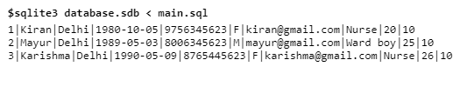

INSERT INTO VISITS Values(1,10,'17-05-01');

INSERT INTO VISITS Values(1,10,'17-05-02');

INSERT INTO VISITS Values(1,20,'17-05-02');

INSERT INTO VISITS Values(2,20,'16-05-02');

INSERT INTO VISITS Values(3,30,'17-08-03');

INSERT INTO VISITS Values(4,10,'17-05-02');

Select * from VISITS;

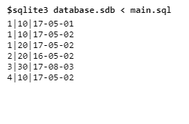

INSERT INTO ATTENDEDBY Values(1,1,'17-05-02');

INSERT INTO ATTENDEDBY Values(1,1,'17-05-03');

INSERT INTO ATTENDEDBY Values(1,2,'17-05-04');

INSERT INTO ATTENDEDBY Values(2,1,'16-05-02');

INSERT INTO ATTENDEDBY Values(4,3,'17-05-02');

Select * from ATTENDEDBY;

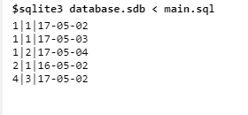

INSERT INTO BILLS Values(1,'17-05-02',2000,3000);

INSERT INTO BILLS Values(1,'17-05-03',5000,6000);

INSERT INTO BILLS Values(1,'17-05-05',8000,4000);

INSERT INTO BILLS Values(2,'16-05-02',2000,3000);

INSERT INTO BILLS Values(4,'17-05-02',2000,7000);

Select * from BILLS;

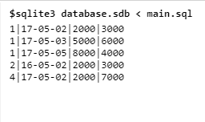

**QUERIES**

1. Find the details of the patient whose name is Ram

Select * from PATIENT where Pname='Ram';

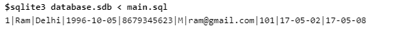

1. Find the patient id of the patients who visited doctor Ajay.

Select Pid from VISITS where Did = (Select Did from DOCTOR where Dname= 'Ajay');

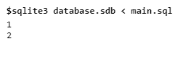

1. Find the names of the patient who are admitted in room 105

Select Pname from PATIENT where Rno=105;

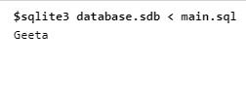

1. Find the total bill amount of the patient Ram on 02 may 17.

Select Roomamount+Medicineamount from BILLS where Pid=(Select Pid from PATIENT where Pname='Ram') AND Billdate='17-05-02';

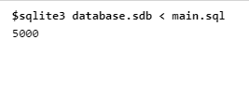

1. Count the total number of available rooms

Select Count(Rno) from ROOMS where Roccupany='available';

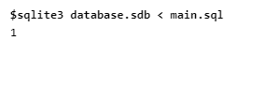

1. Find the Doctor id of the doctors visited by exactly one patient on 02 may 17

Select v.Did

from Patient t, Visits v

where t.pid=v.pid AND Appointmentdate='17-05-02'

group by t.pid

having count(v.did) = 1;

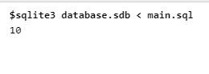

1. Count the number of nurses in the staff

Select count(Sid) from STAFF where Sdesignation='Nurse';

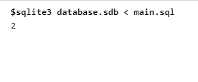

1. Find the total working hours of doctor Pradeep in a month

Select Dworkingdays*Dworkinghrs from DOCTOR where Dname='Pradeep';

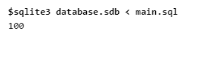

1. Find highest room amount any patient paid on 02 may 17.

Select max(roomamount) from BILLS where Billdate='17-05-02';

